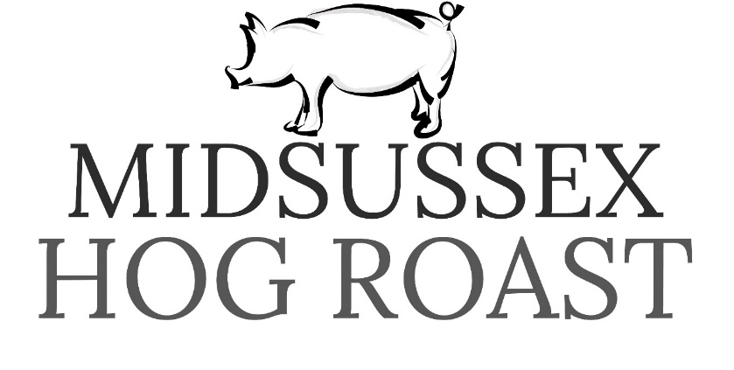

Please see our tasty extras below which can be added to any function or event. We work from our 5/5 hygiene rated professional catering kitchen, all arrives organised and ready. The below is a guide price only and can change depending on time of year, dates, numbers at functions, or if you have accepted previously quoted prices.

Canapes
Home made and very tasty. Perfect for a nibble before the main event.
All served on our stylish slates and with attractive garnishes
Tempura battered prawns with sweet chilli dip - £2.50pp
Garlic mushroom toasts - £2.00pp
Roast beef, Yorkshire puddings with horseradish - £2.00pp
Tomato bruschetta - £1.50pp
Butchers cocktail sausages with honey mustard glaze - £2.00pp
Mozzarella antipasto skewers - £2.00pp
Duck rolls with hoisin sauce - £1.50pp
Chicken tikka skewers - £2.00pp

Desserts
Delicious deserts either served on large help yourself style platters or individually platted. All garnished and beautifully presented

Eaton mess – £1.50p
Chocolate brownie - £4.50pp
Mississippi mud pie - £4.00pp
Lemon tart - £4.50pp
French apple slice - £3.50pp
Winter fruit crumble - £3.50pp
Banoffee pie - £3.50pp
New York Cheese cake - £4.00pp
Chocolate fudge cake - £3.00pp
Eaton mess cheese cake - £4.50pp

SALADS
Delicious, freshly made salads served in large salad bowls. Perfect add on to any package

Tomatoes and Cucumber salad - £1.20pp
Greek salad - £2.00pp
Roasted pepper and rocket - £2.50pp
Moroccan couscous £2.00pp
Tomato and mozzarella - £2.00pp
Mediterranean salad - £1.50pp

We also have on our website – www.midsussexhogroast.co.uk
Our FULL pdf menu with so many more sides, meats, salads and packages.

